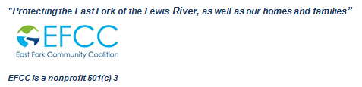

Date: August 5, 2019

Subject: Transcript and Audio clips from Covenant Hearing provided

To: Hearings Examiner and Clark County Councilors,

This letter references questions posed by the Clark County Councilors during the “Council Time held July 31, 2019. At the Dec 11, 2018 Public Hearing, when the Covenant with the Yacolt Quarry expansion was approved, assurance and written guarantees were made to the Councilors and the public. We were assured that nothing would happen on the land as a result of the new covenant. “It is just a map change” (Ref: clips below at 1:44:20 to 1:45:26) Movement of the Overburden would require a permit and ecological study which may prompt mitigation.

Because we value your time, we have researched the highlights from the Dec 11 Hearing. Please make time in your busy schedules to listen to the clips below or read the transcript clips provided. They will answer many of your questions.

The following are from the Dec 11th Hearing after listening to days of testimony and emails from residents at the Aug 2nd Advisory Planning Hearing, and Nov 27th and Dec 4th Hearings with the Clark Co Councilors. Residents took time away from work and their busy schedules because testifying was so very important to the health and safety of their homes and families.
Following the audio times are clips, cut and pasted, from the Dec 11 Hearing transcript by Rider and Associates, Inc. 360.693.4111.

The Audio Link: https://www.cvtv.org/vid_link/27576

00:37:40 to 00:42:58 Christine Cook, county attorney - Summary of new Covenant with the operators agreement to the County

Transcript: During that time period, the Storedahl has agreed to extract -- only use the property that is noted on the map for the storage of excavated material and has specifically agreed not to extract material, mix asphalt, engage in concrete batching, clay bulking, rock crushing, temporary offices, shops, other accessory buildings or structures used for the management, maintenance of mining and processing equipment.

So that list comes from Clark County Code, those are the sorts of uses that could in general occur if a permit were obtained on surface mining overlay land. So here, the Storedahl has agreed not to engage in those, so they won't be applying for a permit to do those things.
In addition, in order to store extracted material, a permit is required, so they will have to obtain a permit to do what they anticipate doing on this property.
BOLDT: And what is that process for that permit?

COOK: That's a conditional use permit. So the decision is made by the Hearing's Examiner in a public proceeding and there is notice and opportunity for the public to comment.
OLSON: And just because this question's come up and I want it to be clear that they are not able to move that overburden onto this parcel without the overlay.
COOK: That's correct.

OLSON: Cannot get a permit to do it unless it's zoned.

ORJIAKO: It's unless it has the surface mining designation. And

if I may add, during the application process or the permit process too, for the storage of the overburden, at that time the County will look at how to mitigate whatever impact that needs to be addressed.
STEWART: And in addition to the conditional use permit requirement, it's my understanding that there would have to be a site plan, it may still require SEPA, geohazard and any environmental reviews that are required.

…COOK: That's correct. This agreement does not at all relieve the applicant from any of the normal proceedings that would be required and decisions and approvals that would have to be made in order for activities related to mining to occur on that property.

00:43:24 to 00:43:41 Councilor Olsen is being assured that permit process is required to move overburden

OLSON: Sorry. One more. And if this overlay is granted, just to put the overburden on this property, they have to go through the permit process?

COOK: That's correct.

OLSON: And the geohazards and the landslides questions? QUIRING: Yes.
ORJIAKO: Right. All applicable County code will be reviewed.

1:16:12 to 11:17:43 Mitch Nicholds - Community Development Director, talks about lack of code enforcement and compliance

NICKOLDS: Sure. As many of the folks who have spoken today have indicated, there has been a huge concern with lax enforcement and compliance at these, at the mine sites. I think it's important to note that once you have a conditional use permit in place, as with any permit that the County issues, compliance is required by
the permit holder regardless as to whether or not the County may observe an infraction at any particular time.

Their responsibility to maintain compliance with their operation or the conditional requirements of those permits is omnipresent, it's always there, it's their responsibility. We do have a responsibility to monitor and to ask for reports to make sure that things are in compliance, ultimately it is the permit holder's responsibility to comply.

1:23:00 to 1:25:08 Councilor Stewart, talks about concerns not handled well in past with CUP and truck traffic

If the County is taking the responsibility to expand the overlay, then we have to find a way to deal with matters that haven't been dealt with well in the past and that is conditional use requirements and the issues of the trucks, how fast they go, how heavily they're loaded, whether or not the loads need to be covered.

So we can't --the County has to be involved between the citizens and the mine operator, somehow we have to be in there and we need to be both the advocates for the citizens and the quality of life in their neighborhoods as best can be done in a mining area and to make sure that the operator has the rights they must have in order to function and to do the mining operation.

So I just want to be careful that we're not taking ourselves out

of the equation, we can't. We have to be in the equation because we're the hammer, the County ends up being the hammer for making sure that the neighbors are as safe as possible and that the trucks and the roads are as safe as possible, so...

1:33:12 to 1:34:32 Councilor Olsen asks Oliver O about EIS required in future and is assured it’s likely

OLSON: Yeah. I do want to just, I'll address a couple of things, but I want to, the question of whether EIS was required, I think your statement was that it's not required for this land use decision today but that in the future if a permit will be applied for, then all of those environmental questions will be answered.
ORJIAKO: It is. Let me frame it this way. It is likely because we have to look at can the issues raised be mitigated under our existing County code and first we have to determine if there is potential adverse environmental impact, and if we determine that and then look at how that could be mitigated and, if it cannot be mitigated using existing County code, then in this case it will not be my shop, it will be Mitch Nickolds shop, they will make a determination to issue an EIS.

OLSON: That's for that action.

ORJIAKO: Yes. Yes. But for this action, it is just to put an overlay, there is no actual application to develop the property, so we did not have a, we made a determination that an EIS is not required, it could be required at a later time.

1:35:16 to 1:35:38 Councilor Olsen asks Operator how much rock left
OLSON: That's about years of mining?

STOREDAHL: Well, that's about 70 million ton, and under the current truck trips that we're limited to, if we were to maximize that for the next, for 50 weeks out of the year, it would be 30 years. So it would be about two and a half million ton that we can move based on the truck trips that we're allowed.

1:36:30 to 1:38:41 Councilor Stewart, for new or changing activity CUP would be required, Environmental Review and possibly Full SEPA required, including landslide areas, Run off, protection of the rivers and more.
STEWART: So I have, I guess two major areas that I'm really interested in. First of all, this still would need to go through a conditional use permit process.

ORJIAKO: That's correct, Councilors.

STEWART: And with the conditional use, conditions may be attached, and for sure before any activity can begin, an environmental review would be required, and how extensive that is for any new or changing activity and this would be a changing activity. It's possible that a full SEPA may be required on this.

I do think it's beneficial rather than expand the full mine operation that we maintain the current footprint of the mining operation, and I think expanding the mining overlay to allow moving the overburden helps maintain it in its current footprint, the mine in its current footprint.

So I'm concerned about, and I believe an environmental review will look at slide areas if there are any, well, there are slide areas up in that area, runoff, protection of the rivers, other environmental protections that will have to be reviewed and those are some of my main concerns and I'm reassured that those will occur.

1:39:11 to 1:40:24 the operator agrees to all of this and more.
Operator: And as far as the landslide, I should mention we have a pit in Castle Rock that has operated within an area that has a landslide issue, and then when the permit was made, they just simply permitted around that landslide issue, made sure that we didn't extract from or stockpile on top of with the understanding that we were relieving weight above that landslide issue.
. . . and if it can't, they wouldn't allow the permit to do so, so there are issues that can come up in any rock pit, but during the application process is where I'm given an opportunity to mitigate those at that time.

1:44:20 to 1:45:38 Councilor Blom, point #3 - any change including overlay requires a permit, there is an additional process.
BLOM: So for the period of ten years there will not be any further extraction on this property. The third thing - thank you, that was my only question I think. - any change is going to require a conditional use permit.

So even to just start using this for overlay, there is going to be another process where many of the concerns that have been addressed are going to be looked at and considered and detailed and mitigation is going to be required, so there's still another process before even using it for overlay will be there.

The fourth thing, any change to the covenant - and this is really important and I'm thankful that we put this in the language - will require coming back to this Council. So if Storedahl in five years wants to come back and say, you know, we want to start extracting earlier, that's not going to go to the Hearing's Examiner, that's going to come right back to this Board and we're going to make that decision at that time as to whether the situation has changed enough where that might be allowable or not.
So we'll have this whole process if they even attempt it or ask for that again, we would come back here and have this process, there would be no shortcuts, no way around it coming before this body.
And then the last point, in ten years if they do decide at that time that they want to extract, there will be another CUP process and another very likely an environmental impact at that point and we'll go through all of those issues again at that time.
The mine operator stated at public hearings and agreed by his signature in the Covenant that the sole purpose of the expanded Surface Mine Overlay (SMO) is to provide for temporary storage of “Overburden” (which is soil and possibly some non-commercial rock interspersed within the soil) removed from the existing mine pit of the Yacolt Mtn. mine. The mine operator agreed that NO mining, NO stock piling of quarried commercial rock, and NO rock crushing operations would occur on the expanded Surface Mine Overlay (SMO) for the duration of the Covenant which does not terminate until December 2028

Please uphold the promises made to North County residents and do not allow the operator to expand the mining operation or pile overburden on top of a landslide area well-known to County Permitting office and WA DNR (as found on their website, Ref: https://geologyportal.dnr.wa.gov/#natural_hazards).

See Screen shot of WA DNR Landslide map following:
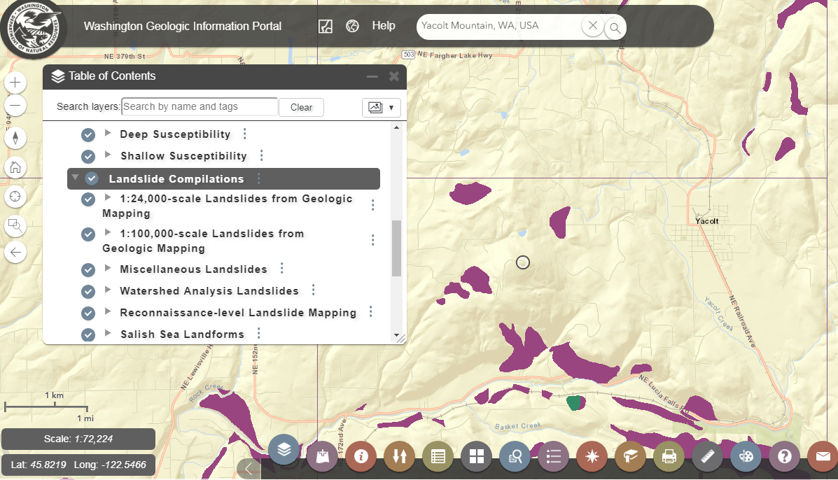

The lack of compliance at the Livingston Mine, as recently documented by state audit, is alarming. This is the same operator. With this history of noncompliance, greater vigilance is required with regard to the Yacolt Mine. Neighbors have voiced alarm and concern for years. Let them use the next 10 years to prove that they can comply with the items in the CUP that Mr. Nicholds references in his audio and transcript clips.

Tests are still in process by SWCAA and the EPA on Yacolt Mountain Quarry. Additional, geoscientists are in the process of acquiring data that will tell us more. Please do not change or grant a change in CUP that includes granting a 10 year or more, (Ref: 30 year statement -1:35:16 audio or transcript time above) early permit “add on” item or action for expanding the current mining area that is based on unknown conditions 10 years or more from now. We have no idea what new or additional risks, impacts, or tradeoffs may be at that time. Allowing a permit to include a mining expansion to be implemented 10 years or more from now with all the risks involved would be totally improper.

Historically and even recently, the county acknowledged the need for much better implementation and follow through on the existing CUP, as well as related monitoring management responsibilities and enforcement. Yet this has not happened in any significant way. Until major change is actually set up and fully operating on the existing CUP – NO CHANGES OR UPDATES IN THE EXISTING CUP SHOULD BE ISSUED. Let the operator use the next ten years to prove that they can comply with the items in the CUP that Mr. Nicholds lists in his audio clip here, a demonstrable record of compliance.

Thank you for your attention to this matter.

Sincerely,
Marie Ogier
East Fork Community Coalition, Admin Assist

